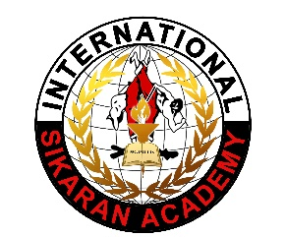
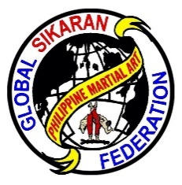
GLOBAL SIKARAN FEDERATION
(Pangbuong Mundong Samahan ng Sikaran)
SEC Reg. No CN201421417
DBA-International Sikaran Academy
GENERAL HEADQUARTERS
Sikaran Bldg. 1122 High St. Delano CA 93215
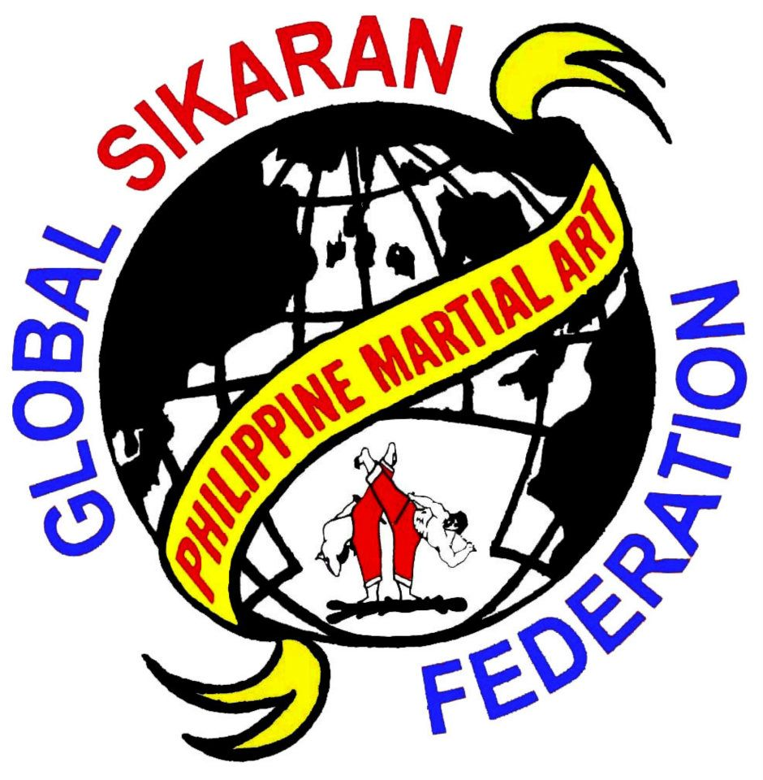

GM HARI OSIAS C. BANAAG
10thDegree RedBelt
Founder/President – G.S.F.
Int’l Director, CEO – I.S.A.

Researcher and Worldwide Propagator of Philippines Indigenous Sports, Sikaran, Arnis and Sickle Weapon.
Successor and heir of the real King of Sikaran of the Past Century, Hari Francisco Torres y Escorpion “ Alyas Kummander Rumagit 98 Years Old, He received the turnover on last June 26, 1994 at Baras, Rizal with Notary Public, Atty. Rafael P. Mateo

Personal Identity:
He started in Martial Art Community on last June 1, 1968 up to the present 52 years, I never stop Teaching and Researching the Philippine Indigenous Sports Sikaran, Arnis and Sickle. At the present I’m in the forefront of promoting Sikaran Worldwide.
I was born in Baras, Rizal (Where the Sikaran was Originated), on February 4, 1959, I’m
the 3rd Sons of Jeremias De Guzman Banaag and Maria Catolos Banaag, I have (4) four Brothers, (1) youngest Sister and also one adopter Sister, my oldest Brother, Evenizer C. Banaag, 2nd Joel C. Banaag, I’m the 3rd one, mym4th brother is Manuel C. Banaag and the youngest brother is Jonathan C. Banaag and youngest Sister Evangeline C. Banaag, our adopted sister is Sister Maricel S. Catolos.

Educations:
2013 BA - San Joaquin Valley Colleges, Visalia, California, U.S.A.
1990 Bible Theology - International Baptist Theological Colleges, Mandaluyong, City,
Philippines
1986 Biogas Technology - University of Life, Pasig, City, Philippines
1980 B.S.E. - Tomas Claudio Memorial Colleges, (Undergraduate)
1976 Tailoring - R.Y.D.F. Baras, Rizal

Experiences:
1976 -President & Founder Foremost Sikaran Brotherhood, Inc., Brgy. Pinugay Baras, Rizal
1976 -Chief Instructor, Sikaran Brotherhood Peterson Farms, Brgy.Pinugay, Baras, Rizal
1976 -Chief Instructor, Sikaran Brotherhood Hybrid Farms, Brgy.,Pinugay, Baras, Rizal
1976 -Chief Instructor, Sikaran Master, Baras, Rizal
1987 -Sikaran Chief Instructor International Theological College, Mandaluyong, City
1987 -Owner Proprietor, Chief Instructor, Sikaran-Arnis Gym, Mandaluyong, City

1987 -Sikaran Instructor, Manuela 1,2,3 Security Guards, Las Pinas and Mandaluyong,
City.
1992 -President & Founder, Philippine Federation of Sikaran Brotherhood
1993 -Sikaran Instructor, Cainta Barangay Tanod, Cainta, Rizal
1994 -Sikaran Instructor, Tomas Claudio Memorial Colleges, Morong Rizal
1988 to 1995 -Chief Instructor, 2 Unit of Militaries:
- Light Armor Brigade 2. Army Honor Guard,
are both in Makati City. Philippines
1995 -Sikaran Instructor, Angono National High School, Angono, Rizal.
1995 - Owner/Proprietor, Chief Instructor “ Sikaran-Arnis Gym “ Baras, Rizal
1997 - Owner/Proprietor – Sikaran – Arnis Academy, Delano California, U.S.A.
1997 - President/Founder GLOBAL Sikaran FEDERATION, Delano, California, U.S.A
1997 - Int’l Director, CEO – International Sikaran Academy, Delano, California

Multiple Times “ HALL OF FAMERS “
From different Martial Arts Organization, Philippines, Canada, United States and Argentina Since 2004, up to Present.
2004 Hall of Fame, “The Sole King of Sikaran “Los Angeles, California, U.S.A.
2005 Hall of Fame “Achievement Awards “Las Vegas, Nevada, Nevada, U.S.A.
2006 Hall of Fame “Sikaran Grandmaster “Los Angeles, California, U.S.A.
2008 Hall of Fame “Doctorate of Martial Arts “ Los Angeles, California, U.S.A.
2011 Hall of Fame “Leading Grandmaster / Outstanding Achievement Award “ Los Angeles, California, U.S.A.
2012 Hall of Fame “Most Distinguished Grandmaster of the Year “Manila, Philippines
2012 Hall of Fame “Martial Arts Chaplain of the Year “Los, Angeles, California,
2013 Hall of Fame “Golden Life Award, Newport, California U.S.A.
2013 Hall of Fame “International Supreme Grandmaster of the Year “Saskatoon, Saskatchewan, CANADA
2014 Hall of Fame “G.S.F. Organizational of the Year “Manila, Philippines
2014 Hall of Fame “International Sikaran Grandmaster of the Year “Manila, Philippines
2014 Hall of Fame “Supreme International Grandmaster of the Year “San Diego, California, U.S.A.
2014Hall of Fame “Elite Black belt Martial Arts Hall of Fame, Fresno California, U.S.A.
2015 Hall of Fame “Lifetime Achievements Awards “Las Vegas Nevada.,
2016 Hall of Fame “Outstanding Achievements in Martial Arts As A Grand Master “Atlantic City, New Jersey
U.S.A.2016 Hall of Fame “Inspiration to all Martial Artist “Las Vegas, Nevada, U.S.A. 2016 Hall of Fame “Argentina Hall of Fame “Buenos Aires, Argentina
2017 Hall of Fame “Distinguished Sikaran Grandmaster of the Year,”, Makati, City Philippines
2017 Hall of Fame “Platinum Achievements Award “Fullerton, California, U.S.A.
2018 Hall of Fame “Distinguished Grandmaster Award, Atlantic City, New Jersey, U.S.A.
2018 Hall of Fame “International Living Legend Award “Fullerton C, California, U.S.A.
2018 Hall of Fame “Grandmaster of the Year Award “Riverside
2018 Hall of Fame “All Pro Tae Kwon Do “Los Gatos California, U.S.A

2019 Hall of Fame “Outstanding Sikaran Grand Master Award “Delano California, U.S.A.
2019 1st Bayanihan the Hero of FMA, Luneta Hotel T.M. Kalaw MANILA, Philippines.
2019 Hall of Fame “Outstanding Sikaran Grand Master Award “Fullerton California, U.S.A.
2019 “ All Pro Tae Kwon Do Hall of Fame, Los GATOS California, U.S.A.
2020 “ International Propagators of Philippine Indigenous Sports Award, Fullerton California, USA

Special Awards:
January 2004 “Letter of Commendation “ Signed By: President Kukkiwon Un Yong Kim
December 2004 “The Presidential Active Lifestyle Award “Signed by the President of the United States George W. Bush
2004 to 2006 “Best School Award “Tae Kwon Do Tournaments
August 26, 2017 “Presidential Active Lifestyle Award “ Signed by
Congresswoman Susan A. Davis

August 5, 2018 “Living Legend Award “Fresno California, U.S.A.

Affiliated Member:
United States Karate Alliance
International Martial Arts Council
World Martial Arts Council
U.S.A. Martial Arts Hall of Fame
Elite Black Belt Hall of Fame
International Association of Combative Sports IACS.
Member Adhoc Advisory of Traditional Sports and Games UNESCO (2017 to 2019)

Meeting Attended:
March 22 to 27, 1997 I was attended the World Martial Arts Convention for World Peace, In Washing DC., U.S.A.
September 3 to 8, 2016, Geonju Martial Arts Festival, Geonju City, Korea
July 6 & 7, 3rd Collective Consultation Meeting of UNESCO TSG, in Paris France
September 11 to 16, 2018, 4th Collective Consultation Meeting of UNESCO TSG, in Istanbul, Turkey.
April 21 & 22, 2019, 2nd International Ethnosport Forum, in Almaty, Kazakhstan.

Recognitions:
February 21, 2011, Office of Sanguniang Bayan, Municipality of Baras Province of Rizal Resolution No. 051-s-2011.
October 27, 2014, Office of Sanguniang Bayan, Municipality of Baras Province of Rizal
Rersolution 128 -s- 2014.
2017 up to 2019 Member Adhoc Advisory Committee, of Traditional Sports and Games UNESCO.
February 2018 “Plaques of Appreciation as Guest Speaker, Given by Tomas Claudio College, Morong, Rizal Philippines.
January 26, 2019 Plaque’s of Appreciation, Given by World Citi College, Antipolo, City, Philippines
September 12 to 16, 2018, Received Certificate of Appreciation from the President of World Ethnosport Confederation, Istanbul Turkey.
April 21 to 22, 2019, Received Certificate of Appreciation from International Ehnosports Forum, Almaty, Kazakhstan.
August 5, 2019, Office of Sanguniang Bayan of Tanay, Municipality of Tanay province of Rizal, Resolution No. 157, Series of 2019.

August 28, 2019, Office of Sanguniang Bayan of Tanay, Municipality of Tanay province of Rizal. Accreditation No. 08-04-2019, O.R. No. 12479085.
December 2, 2019, Office of the Sanguniang Panglalawigan ng Rizal, Provinicial Capitol, Antipolo, City Province of Rizal, Resolution No. 608 -s- 2019, Issued Certificate of Accreditation of Non-Government Organization/People’s Organization, Issued December 2, 2019.

Conducted Seminars:
January 1992, Sikaran Advanced Standardization Seminar, Baras, Rizal, Philippines.
February, 1992, Sikaran Basic Standardization Seminar, Baras, Rizal, Philippines.
May, 2012, Sikaran Standardization Seminar, Perth Australia
May, 2015, Sikaran Standardization Seminar, Baras, Rizal, Philippines.
September 4, 2017, Sikaran Standardization Seminar, Baras Gym, Baras, Rizal,Philippines.
September 27, 2019, Chula Vista, Sandiego, California, USA.
October 17, 2020, Fullerton, California, USA, USA Hall of Fame 2020

Global Sikaran International Branches:

GSF Vice President Mst’r German Patingo Philippines
GSF Vice President Mst’r Paul O. Villamor Canada
GSF Vice President Inst’r Harshad Salla India
GSF Vice President Inst’r Prasad Wickramasinghe Sri Lanka
GSF Vice President Inst’r Rodelo Ubaldo Italy
GSF Vice President Inst’r Abubakkar Siddy Kamara Sierra Leone
GSF Vice President Mst’r Manuel C. Banaag Saudi Arabia GSF Vice President Mst’r Emmanuel M. Banaag United States
GSF Vice President (Inst’r Roger Fellite) Australia GSF Vice President Inst’r Syndool Mwigaya Tanzania
GSF Vice President Inst’r Chabbane Akkache Algeria GSF Vice President Inst’r Francisco Javier Farrel Argentina
GSF Vice President Inst’r Ganesh Bahadur Kunwar Nepal GSF Vice President Inst’r Allan Whiteside United Kingdom
GSF Vice President Inst’r Angel Norberto Carino Cruz Mexico

At Present Global Sikaran Federation has a 15 Countries Affiliated Member.

Ud/111020

